**Lab 5**

**Views in SQL**

**Objectives: Create views, drop views and perform different queries using views**

1. Create a view which contains information about employee’s fullname, email and office city location.

**Source Code:**

create view employeeBrief as

(select concat(e.firstName,' ',e.lastName) as "Full Name",e.email,o.city

from employees e, offices o

where o.officeCode=e.officeCode);

select * from employeeBrief;

**Output:**

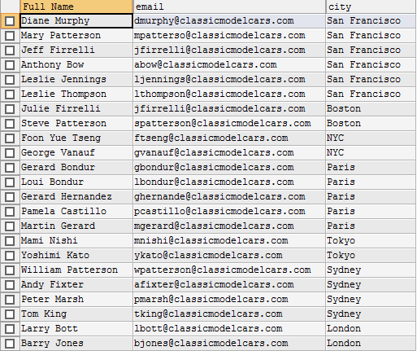

1. Create a view that contains information about customerNumber, customerName, Full contact name, orderNumber, order status and total amount of each order.

**Source Code:**

create view customerBrief as

(select c.customerNumber, c.customerName, concat(c.contactFirstName,' ',c.contactFirstName) as "Full Contact Name", o.orderNumber, o.status, (od.quantityOrdered*od.priceEach)

from customers c, orders o, orderdetails od

where c.customerNumber=o.customerNumber and o.orderNumber=od.orderNumber

group by o.orderNumber);

select * from customerBrief;

**Output:**

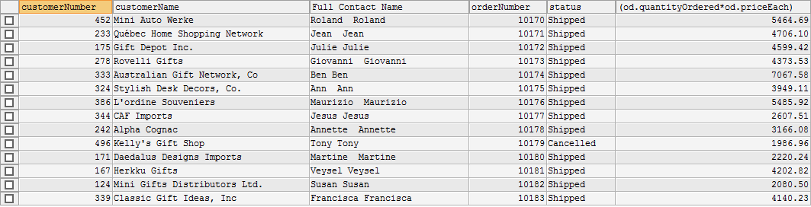

1. Create a view that contains information about customer name, customer city, product name and quantity of given product ordered by all customers.

**Source Code:**

create view storeBrief as

(select c.customerName, c.city, p.productName, sum(quantityOrdered) as "Quantity ordered by all"

from customers c, orders o, orderdetails od, products p

where c.customerNumber=o.customerNumber and o.orderNumber=od.orderNumber and od.productCode=p.productCode

group by c.customerNumber);

**Output:**

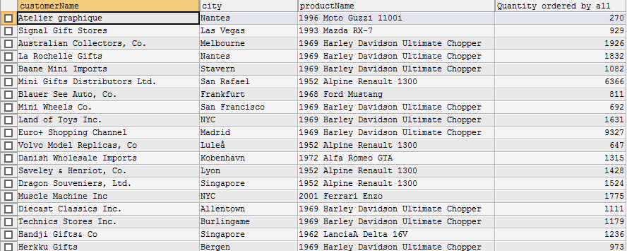

1. Create a view that contains information about customer number, customer name, total amount paid by each customer.

**Source Code:**

create view amountBrief as

(select c.customerNumber, c.customerName, sum(od.quantityOrdered*od.priceEach) as “T”

from customers c, orders o, orderdetails od

where c.customerNumber=o.customerNumber and o.orderNumber=od.orderNumber

group by c.customerNumber);

select * from amountBrief;

**Output:**

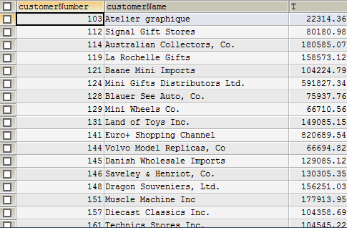

1. Create view that contains information about product details for products ordered by customer residing in city ‘NYC’.

**Source Code:**

create view nycBrief as

(select distinct p.*

from customers c, orders o, orderdetails od, products p

where c.customerNumber=o.customerNumber and o.orderNumber=od.orderNumber and p.productCode=od.productCode

and c.city="NYC");

select * from nycBrief;

**Output:**

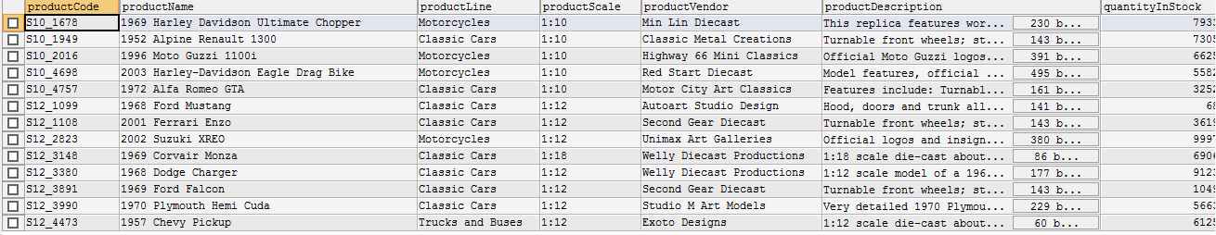

1. Update view in question number 1 to add information about employee’s job title.

**Source Code:**

CREATE OR REPLACE VIEW employeeBrief AS

(SELECT CONCAT(e.firstName,' ',e.lastName) AS "Full Name",e.email,o.city,e.jobTitle

FROM employees e, offices o

WHERE o.officeCode=e.officeCode);

**Output:**



1. Update view in question number 5 to information about product details for products ordered by customer residing in city ‘Las Vegas’ and ‘San Francisco’.

**Source Code:**

CREATE OR REPLACE VIEW nycBrief AS

(SELECT DISTINCT p.*

FROM customers c, orders o, orderdetails od, products p

WHERE c.customerNumber=o.customerNumber AND o.orderNumber=od.orderNumber AND p.productCode=od.productCode

AND (c.city="Las Vegas" OR c.city="San Francisco"));

**Output:**

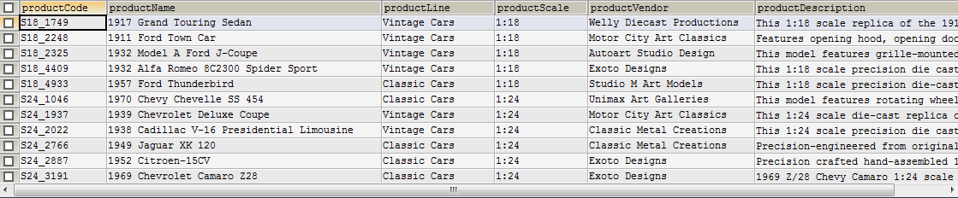

1. Using view created in question number 4, find out the total amount paid by customer in each city.

**Source Code:**

SELECT SUM(a.T),c.city

FROM customers c, amountBrief a

WHERE c.customerNumber=a.customerNumber

GROUP BY c.city;

**Output:**

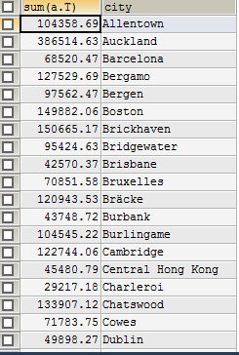

**Conclusion:**

Thus, Create views, drop views and different queries using views can be done as above.